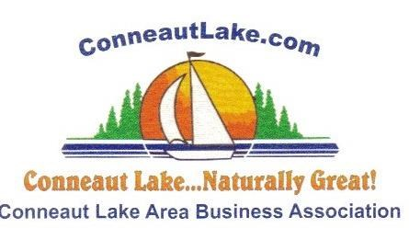

13th Annual
FESTIVAL OF THE ARTS & CRAFTS
Saturday & Sunday, July 6 & 7, 2024
Conneaut Cellars Winery, Conneaut Lake, PA

You are invited to come and share your creative talents at the 13th Annual Festival of the Arts, Crafts & Gifts on Sat. & Sun., July 6 & 7, 2024.

Spaces will be 12’ x 12’. Vendors will be responsible to provide their own tables, chairs, displays & cover.

Registration and set-up will Friday, July 5, from 2:00 p.m. to 7:00 p.m. and Saturday, July 6 from 7:00 a.m. to 9:30 a.m.

Show hours are Saturday and Sunday, 10:00 a.m. to 5:00 p.m.

Yard signs, banners, & newspaper articles will be used to advertise this event.

For information, please call BJ Murray 814-547-1950 or call Pat McGee at 814-671-6885 or email conneautlakebusiness@gmail.com

Festival of the Arts & Crafts is sponsored by the Conneaut Lake Area Business Association.

2024 Pumpkin Fest:
Join us in October for our 33rd Annual Pumpkin Fest
Fri, Sat, & Sunday Oct 11, 12, & 13th
Visit our website for more information
https://www.conneautlake.com/event/2022-pumpkin-fest/

