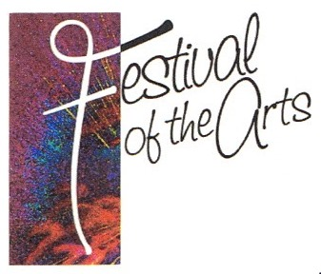
12th Annual
FESTIVAL OF THE ARTS & CRAFTS
CONNEAUT CELLARS WINERY
12005 Conneaut Lake Rd
Conneaut Lake, PA
Saturday & Sunday, July 1 & 2, 2023

Vendor’s Name ________________________________________________________________

Business Name ________________________________________________________________

Address ____________________________ City ___________________ State _______Zip _____

Email ______________________________________________

Phone ______________________________________________

Description of items to be displayed/sold ____________________________________________

_____________________________________________________________________________

______ Number of 12’ x 12’ outside spaces needed ($75/space)

______ Amount included with application.

Pictures of items to be displayed/sold at your booth must be included with your application unless you have participated in a previous Festival of the Arts or Fall Pumpkin Fest events.

Make check payable to Conneaut Lake Area Business Association (CLABA).

Deadline June 25, 2023. Limit of 45 spaces.
Mail completed application & check to: CLABA, P.O. Box 646, Conneaut Lake, PA 16316.
For more information, please call Becky Leonard at the CLABA hot line: 814-720-2917 or email conneautlakebusiness@gmail.com
*****************************************************************************
FESTIVAL OF THE ARTS & CRAFTS 2023 WAIVER

I, the undersigned, agree to abide by the terms and conditions set forth on the information sheet. I understand that if I fail to comply with the rules of the Festival of the Arts & Crafts 2023, I may be asked to leave, and that the booth fee is non-refundable. I do not hold the Festival of the Arts, CLABA, or Conneaut Cellars liable for loss due to damage, theft, or destruction of personal property during set-up, show, or teardown during of the Arts & Crafts 2023.

Signature __________________________________________Date ______________________________

