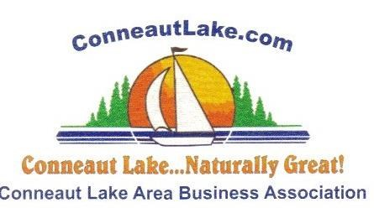

10th Annual
FESTIVAL OF THE ARTS, CRAFTS & GIFTS
Saturday & Sunday, July 3 & 4, 2021
Conneaut Cellars Winery, Conneaut Lake, PA

You are invited to come and share your creative talents at the 10th Annual Festival of the Arts, Crafts & Gifts on Sat. & Sun., July 3 & 4, 2021.

Spaces will be 12’ x 12’. Vendors will be responsible to provide their own tables, chairs, displays & cover.

Registration and set-up will Friday, July 2, from 4 p.m. to 7 p.m. & Sat., July 3 from 7 a.m.-9:30 a.m.

Show hours are Sat. & Sun.—10-5.

Yard signs, banners, & newspaper articles will be used to advertise this event.

For information, please call 814-720-2917 or email conneautlakebusiness@gmail.com

Festival of the Arts & Crafts is sponsored by the Conneaut Lake Area Business Association

